- The Coversheet

Student Name  (unless anonymised) | N/A
Student Number
(as shown on student ID card):
Word Count / Pages / Duration / Other Limits: | N/A
Attempt Number: | 1 of 1
Date of Submission: | 28th of May 2026, 12 Noon

I have read and understood the Academic Misconduct statement. | Tick to confirm ☒
I have read and understood the Generative Artificial Intelligence use statement. | Tick to confirm ☒
I am satisfied that I have achieved the Learning Outcomes of this assignment  (please check the Assignment Brief if you are unsure) | ​​​ Met ☒

Self-Assessment – If there are particular aspects of your assignment on which you would like feedback, please indicate below.
Optional for students
Suggested prompt questions-
How have you developed or progressed your learning in this work?
This project improved my practical understanding of cloud computing, Azure Machine Learning, big data analytics, NLP, and machine learning implementation using real-world datasets.

What do you feel is the strongest part of this submission?
The strongest part of this submission is the successful integration of cloud computing, data preprocessing, machine learning, and business analytics within a practical Azure cloud environment.
What feedback would you give yourself?
I would improve my understanding of advanced Azure services and spend more time exploring distributed big data processing technologies such as Spark and Synapse Analytics.
What part(s) of this assignment are you still unsure about?
I am still developing confidence in configuring large-scale enterprise cloud architectures, especially advanced networking, distributed computing, and automated deployment pipelines. No. 2 question I am unsure if its supposed to be tailored towards the dataset I selected or it was meant to be a general answer. My answer wasn’t tailored towards the dataset. However, I have a architecture design in my artefacts tailored towards my dataset implementation.

- Assessor’s Feedback (may be delivered in line with the submission)

Were the learning outcomes met? | Yes ☐ If not, what was not met:
Assessor’s response to the student’s submission, request for feedback and / or self-assessment (feedback):

What specific actions should the student undertake to progress their learning? (feedforward):

Please take this and other feedback to your next academic tutorial to plan your future work.

Executive Summary
This project focused on designing a scalable cloud-based big data analytics solution for analyzing Amazon Beauty Reviews using the Microsoft Azure cloud platform. The aim was to demonstrate how cloud computing, machine learning, and Natural Language Processing (NLP) can help organizations transform large volumes of customer-generated data into meaningful business insights.
The dataset was stored and processed within Azure Machine Learning, where preprocessing techniques such as duplicate removal, feature selection, and text cleaning were applied to improve data quality. Sentiment analysis and machine learning models including Logistic Regression, Naïve Bayes, and Random Forest were implemented to analyses customer opinions and predict sentiment patterns.
The project also explored important enterprise considerations such as cloud cost optimization, security, access control, encryption, compliance, performance monitoring, and system management. Azure services including Azure Data Lake Storage, Azure Monitor, and Azure Machine Learning were used to support scalable and efficient analytics operations.
Overall, the project demonstrates a practical and cost-effective cloud analytics architecture capable of supporting data-driven decision-making, customer insight generation, and scalable big data processing within a modern enterprise environment.

Table of Content
Executive Summary 4
Table of Content 5
List of Figures 7
List of Tables 7
List of Charts 7
3 Data Ingestion and Storage 9
3.1 Types and Sources of Data the Company Deals with 9
3.2 Propose Cloud-Based Storage Solution 10
3.3 Data Ingestion Process 10
4 Scalable Processing Architecture (15%) 12
4.1 Design of Scalable Big Data Processing Architecture 12
4.2 Discussion 12
4.3 Handling Growing Data Volumes 14
5 Data Extraction and Pre-processing 16
5.1 Selection of Dataset for Extraction and Analysis 16
5.2 Data Extraction Process 21
5.3 Data Pre-processing 22
5.3.1 Handling of Missing and Non-Informative Values 23
5.3.2 Duplicate Record Identification and Removal 23
5.3.3 Feature Selection 23
5.3.4 Text Cleaning and Normalization: 24
6 Data Analysis and Insights 25
6.1 Cloud-Based Analytics Implementation 25
6.1.1 Customer Rating Distribution Analysis 26
6.1.2 Helpful vote Analysis (Engagement Insight) 27
6.1.3 Verified Purchase Analysis 29
6.1.4 Word Frequency Analysis 30
6.2 Machine Learning Model – Sentiment Classification 31
6.2.1 Analysis Overview 31
6.2.2 Feature Engineering and Text Vectorization 32
6.2.3 Model Training 32
6.2.4 Model Evaluation 32
6.3 Contribution of the Analysis to Informed Decision-Making within the Enterprise 34
7 Cost Optimization Strategies 36
7.1 Cost-Effective Cloud Storage Strategy 36
7.1.1 Compressed File Storage 36
7.1.2 Tiered Storage Strategy 37
7.1.3 Data Minimization 37
7.2 Compute Resource Optimization 37
7.2.1 On-Demand Compute Usage 38
7.2.2 Scalable Compute Allocation 38
7.2.3 Efficient Model Selection 38
7.3 Resource Utilization Optimization 39
7.4 Reserved Instances and Pricing Optimization 39
7.5 Monitoring and Cost Governance 39
8 Security and Compliance 41
8.1 Security Measures for Data Confidentiality and Integrity 41
8.1.1 Compliance Considerations in Regulated Industries 42
8.2 Access Control Mechanisms and Encryption Practices 43
8.2.1 Access Control Mechanisms 44
8.2.2 Encryption Practices 45
9 Performance Monitoring and Troubleshooting 47
9.1 Performance Monitoring Strategies 47
9.1.1 Troubleshooting and Bottleneck Management 48
9.2 System Management and Monitoring Tools 49
References 51
10 Appendix 53

List of Figures
Figure 1: Azure-based big data Lakehouse architecture for ingesting, processing, storing, analyzing, and visualizing large-scale Amazon Reviews dataset. 8
Figure 2: Screenshot showing the creation of a storage account 13
Figure 3: Screenshot showing successfully created storage account 13
Figure 4: Screenshot data upload to the storage (a) 13
Figure 5: Screen showing data upload to the storage account (b) 14
Figure 6: Screenshot showing the creation of Azure Machine learning workspace 14
Figure 7: Screenshot showing the Machine learning workspace overview (a) 15
Figure 8: Screenshot showing the Machine learning workspace overview (b) 15
Figure 9: Screenshot showing the creation of a compute instance (a) 16
Figure 10: Screenshot showing the creation of copute instance (b) 16
Figure 11: Screenshot showing how code was used to load the dataset directly without manual decompression 17
Figure 12: Screenshot showing how text columns was cleaned and normalized 20
Figure 13: Screenshot showing Sentiment score on the text column 21
Figure 14: Screenshot showing storage account overview 32
Figure 15: Screenshot showing data storage in compressed format 33
Figure 16: Screenshot showing cloud-based compute configuration 34

List of Tables
Table 1: Dataset Overview 18
Table 2: Sentiment score definition 21
Table 3: Customers Ratings definition 23
Table 4: Model Accuracy Comparison 28
Table 5: Compute configuration overview 34
Table 6: Role base access control 40

List of Charts
Chart 1: Text review was more positive than negative 23
Chart 2: We have more 5-star ratings from the distribution as seen 24
Chart 3: The visualization above illustrates the relationship between customer ratings and the average number of helpful votes received across reviews within the dataset. 25
Chart 4: The results revealed that approximately 90.5% of all reviews were submitted by verified purchasers, while only about 9.5% originated from unverified purchases. 26
Chart 5: The word frequency analysis was conducted to identify the most commonly occurring words within customer reviews after the text preprocessing and normalization stage. 27
Chart 6: Machine Learning Model Accuracy Comparison 30

Data Ingestion and Storage

Types and Sources of Data the Company Deals with
As a data architect within a multinational enterprise, the data landscape I manage is inherently complex, both in volume and variety. The organization operates across multiple regions and business units, which means data is continuously generated from customer interactions, operational systems, and external platforms.
From a practical standpoint, the data can be categorized into three primary types:
Structured data is generated from transactional systems such as order management platforms, ERP systems, and product catalogues. In the context of this project, fields such as ratings, timestamps, product IDs, and verified purchase indicators fall into this category. These datasets are typically well-defined and stored in tabular formats, making them suitable for SQL-based querying.
Semi-structured data forms a significant portion of our ingestion workload. This includes JSON and CSV files sourced from APIs, web logs, and third-party datasets. The Amazon Reviews 2023 dataset, which I have selected for this project, is largely semi-structured. It contains nested fields such as review metadata, product attributes, and user interactions, requiring transformation before efficient downstream processing.
Unstructured data, particularly free-text customer reviews, is where most of the business value lies. These reviews capture customer sentiment, product feedback, and behavioral patterns. However, from an engineering perspective, they introduce complexity because they require natural language processing techniques before they can be meaningfully analyzed.
From a sourcing perspective, the enterprise ingests data from:
- Internal systems (ERP, CRM, transaction systems)
- Digital platforms (web and mobile applications)
- External sources (e-commerce platforms, social media, third-party datasets)
For this assignment, I am working with the Amazon Reviews 2023 dataset, which is widely used in large-scale NLP and recommendation system research due to its size and richness (McAuley Lab, 2023).
In practice, handling this mix of structured, semi-structured, and unstructured data requires a storage and ingestion strategy that is both flexible and scalable.

Propose Cloud-Based Storage Solution
To support this data landscape, I have designed the storage layer using Azure Data Lake Storage Gen2 (ADLS Gen2) as the central repository.
In my experience, ADLS Gen2 provides the right balance between scalability, performance, and integration with Azure-native analytics services such as Databricks and Synapse. It allows me to store raw and processed data in a single, unified environment while supporting hierarchical organization.
I have structured the data lake using a medallion architecture, which is a pattern I consistently apply in enterprise data platforms:
- The Bronze layer stores raw ingested data exactly as received. This is critical for traceability and reprocessing when needed.
- The Silver layer contains cleaned and standardized data. At this stage, I typically remove duplicates, handle missing values, and normalize schemas.
- The Gold layer is designed for consumption, where data is aggregated and optimized for analytics, reporting, and machine learning workloads.
From a scalability standpoint, ADLS Gen2 allows me to handle datasets that scale into terabytes and beyond without requiring changes to the underlying architecture. This is particularly important for the Amazon Reviews dataset, which is inherently large and continuously growing.
For redundancy and availability, I configure the storage account using Geo-Redundant Storage (GRS) in production environments. This ensures that data is replicated across regions, providing resilience against regional outages. In scenarios where latency is critical, Zone-Redundant Storage (ZRS) can be used within a region.
Cost management is also a key consideration in my design. I implement lifecycle management policies to automatically move data across storage tiers:
- Hot tier for active datasets
- Cool tier for infrequently accessed data
- Archive tier for historical datasets
This approach ensures that storage costs are optimized without compromising accessibility (Microsoft, 2023a).

Data Ingestion Process
From an implementation perspective, I have designed the ingestion pipeline using Azure Data Factory (ADF) as the primary orchestration tool.
In practice, ADF allows me to build robust, repeatable pipelines that can handle large-scale data movement with minimal manual intervention. For this project, the ingestion workflow for the Amazon Reviews dataset is structured as follows:
First, the dataset is sourced from a public repository such as Hugging Face. Given the size of the dataset, I typically ingest it in batches or by category to avoid bottlenecks.
Using ADF Copy Activities, I move the raw dataset directly into the bronze layer of ADLS Gen2. At this stage, I preserve the original format (typically JSON) to maintain data fidelity.
Once the data lands in the data lake, I trigger downstream processing using Azure Databricks. Here, I perform initial validation checks, such as schema consistency and file integrity. I then transform the dataset into Parquet format, which significantly improves performance for large-scale analytics.
The cleaned and transformed data is stored in the silver layer, where it becomes suitable for structured querying. From there, I generate aggregated datasets such as sentiment distributions and product-level summaries which are stored in the gold layer.
To ensure operational efficiency, I configure ADF triggers to automate the pipeline. This allows the ingestion process to run on a schedule or in response to new data availability.
In addition, I integrate Microsoft Purview for data governance. This enables me to track data lineage, maintain a centralized data catalogue, and enforce data policies across the pipeline.
From an architectural standpoint, separating ingestion from processing allows the system to scale independently. This is a principle I consistently apply in production systems, as it improves flexibility and fault tolerance (Armbrust et al., 2021).

Scalable Processing Architecture (15%)

Design of Scalable Big Data Processing Architecture
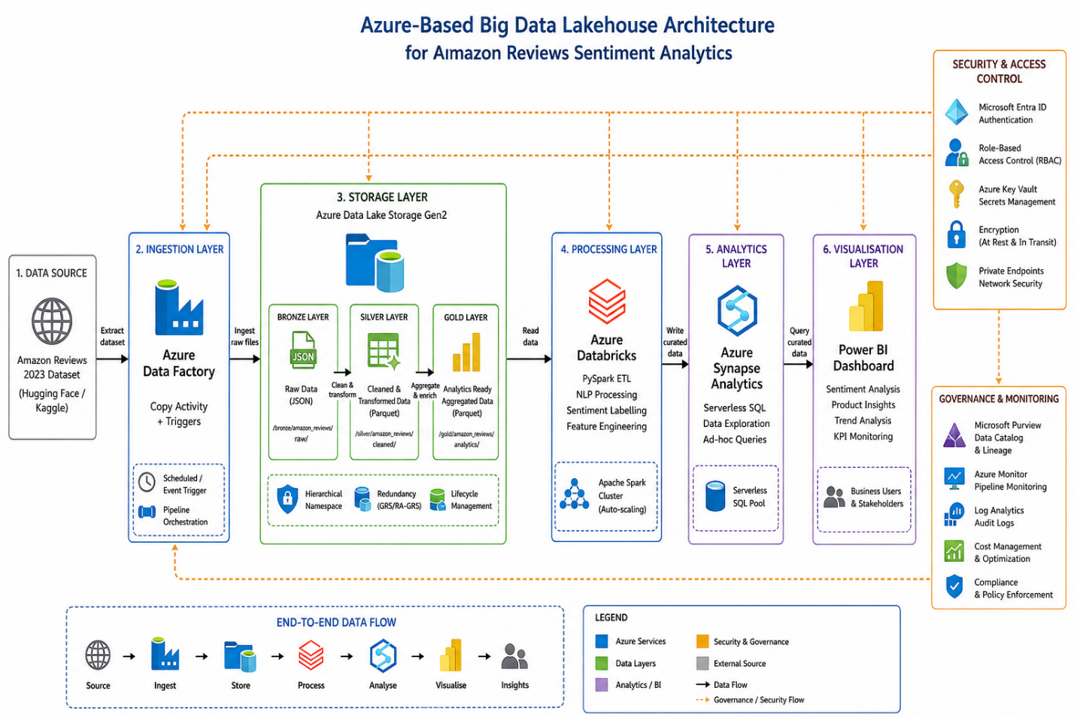
Figure 1: Azure-based big data Lakehouse architecture for ingesting, processing, storing, analyzing, and visualizing large-scale Amazon Reviews dataset.
In designing the processing layer for this project, my objective was to build an architecture that can handle large-scale, distributed data processing efficiently while remaining flexible and cost-aware.
From an implementation standpoint, I adopted a lakehouse-style architecture on Azure, which combines the strengths of data lakes and data warehouses. This is particularly suitable for the Amazon Reviews dataset due to its mix of structured and unstructured data.

Discussion
The architecture I designed is as follows:
Data Source → Azure Data Factory → Azure Data Lake (Bronze/Silver/Gold) → Azure Databricks (Processing) → Azure Synapse Analytics (Query Layer) → Power BI (Visualization)
In practice, the flow works like this:
Data is ingested into the Bronze layer using Azure Data Factory.
Azure Databricks (Apache Spark) processes the data in a distributed manner, handling transformations such as cleaning, deduplication, and feature engineering.
Processed data is written into the Silver layer, and further aggregated into the Gold layer.
Azure Synapse Analytics (serverless SQL) provides a querying interface for analysts without requiring data movement.
Power BI connects directly to the Gold layer or Synapse for reporting and dashboards.
This architecture ensures that compute and storage are decoupled, which is a key design principle in modern cloud data platforms. It allows me to scale compute resources independently based on workload demands without affecting storage.
From experience, this separation significantly improves both performance and cost efficiency.
Choice of Cloud Services for Distributed and Parallel Processing
The core processing engine in this architecture is Azure Databricks, which runs Apache Spark.
I selected Databricks because:
- It supports distributed data processing across multiple nodes, which is essential for handling large datasets like Amazon Reviews.
- It allows for parallel execution of tasks, significantly reducing processing time.
- It integrates seamlessly with Azure Data Lake and other Azure services.
- It supports both batch and real-time processing, providing flexibility for future extensions.
In practical terms, when processing the dataset:
Each Spark worker node processes a partition of the data.
Tasks such as text cleaning, sentiment classification, and aggregation are executed in parallel.
This ensures that even very large datasets can be processed efficiently within reasonable timeframes.

For SQL-based analytics, I used Azure Synapse Serverless SQL Pool. This allows analysts to query data directly from the data lake without provisioning infrastructure, following a pay-per-query model.
For orchestration, Azure Data Factory manages pipeline execution, ensuring that ingestion and processing steps are coordinated and automated.
This combination of Databricks, Synapse, and Data Factory provides a robust distributed computing environment that is both scalable and production-ready.

Handling Growing Data Volumes
One of the key requirements in enterprise data architecture is the ability to scale seamlessly as data volume increases.
In this design, scalability is achieved through several mechanisms:
1. Horizontal Scaling (Compute Layer)
Azure Databricks clusters can scale horizontally by adding more worker nodes. This allows the system to handle increasing data volumes without redesigning the architecture.
In practice, I configure auto-scaling clusters, which dynamically adjust resources based on workload. This ensures optimal performance while avoiding unnecessary costs.
2. Data Partitioning
To improve performance and scalability, I partition the dataset by:
- Year
- Product category
- Sentiment
Partitioning ensures that queries only scan relevant subsets of data, reducing processing time and cost.
3. Efficient Data Formats
Raw JSON files are converted into Parquet format, which is columnar and highly compressed.
This provides:
- Faster query execution
- Reduced storage footprint
- Lower I/O overhead
4. Decoupled Storage and Compute
Because storage (ADLS Gen2) and compute (Databricks/Synapse) are independent:
- Storage can scale infinitely
- Compute resources can be provisioned on demand
This is a fundamental advantage of cloud-native architectures.
5. Serverless Querying
Using Synapse Serverless SQL, the system avoids maintaining dedicated infrastructure for analytics. As data grows, queries scale automatically based on demand.
Architectural Insight (Master’s Level Reflection)
From a design perspective, this architecture aligns with modern data lakehouse principles, where a unified platform supports both data engineering and analytics workloads (Armbrust et al., 2021).
More importantly, it reflects a shift from traditional monolithic systems to distributed, cloud-native architectures, where scalability is achieved through:
- Parallel processing
- Elastic compute resources
- Distributed storage systems
This ensures that the enterprise can continue to derive value from its data even as volume, velocity, and variety increase.

Data Extraction and Pre-processing

Selection of Dataset for Extraction and Analysis
For this project, the Amazon Beauty Reviews dataset was selected as the primary dataset for extraction and analysis. The dataset belongs to the Natural Language Processing (NLP) domain and contains large-scale customer review data collected from Amazon’s e-commerce platform. The dataset includes product reviews, ratings, review summaries, timestamps, and product metadata stored in compressed JSON Lines (.jsonl.gz) format.
The dataset was selected because it reflects real-world enterprise big data characteristics, including:
- Large data volume
- Semi-structured data format
- High variability in customer-generated text
- Unstructured review content suitable for sentiment analysis and machine learning
Additionally, the dataset provides valuable business intelligence opportunities, such as customer sentiment analysis, product performance evaluation, and behavioral trend identification.
The following files were utilized:
- All_Beauty.jsonl.gz – customer review dataset
- meta_All_Beauty.jsonl.gz – product metadata dataset
The datasets were initially stored in Microsoft Azure Data Lake Storage Gen2 before being processed within Azure Machine Learning Workspace.

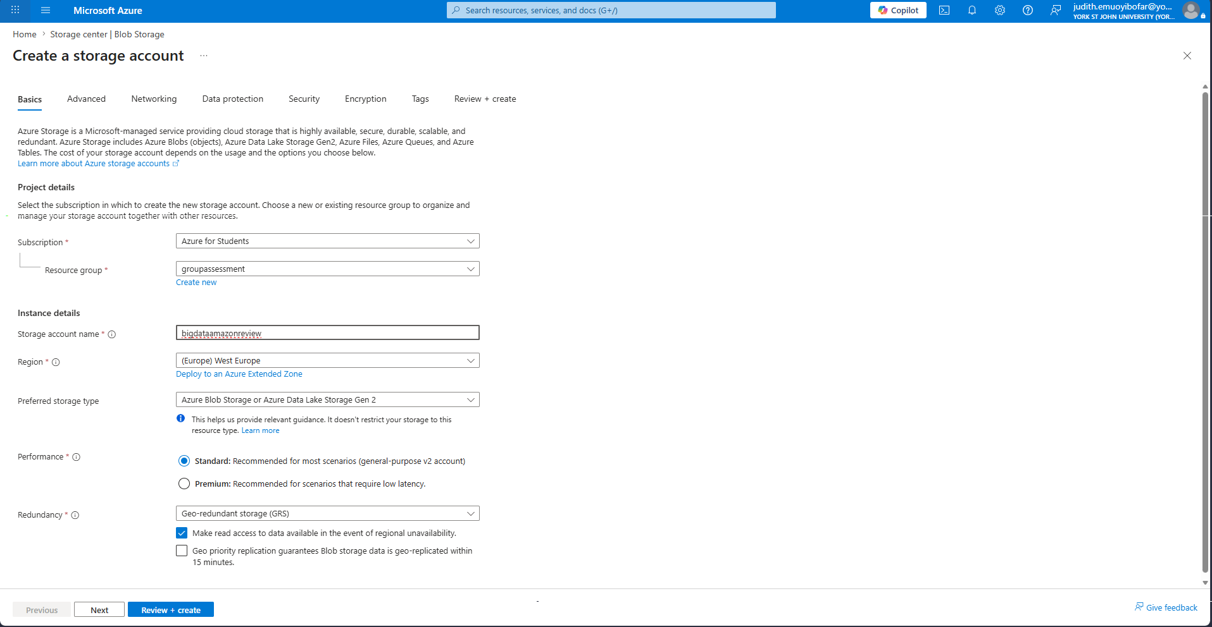
Figure 2: Screenshot showing the creation of a storage account

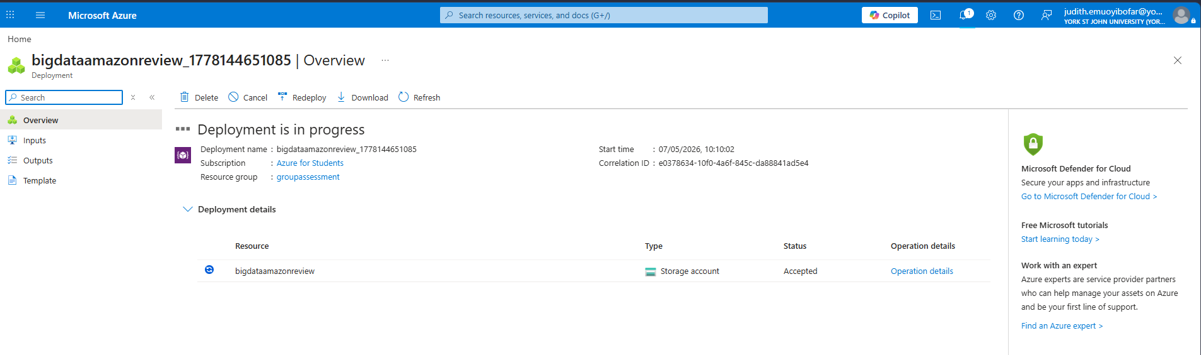
Figure 3: Screenshot showing successfully created storage account
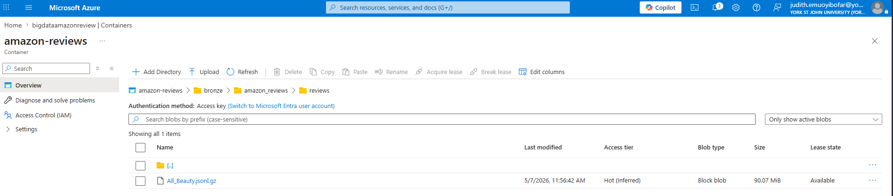
Figure 4: Screenshot data upload to the storage (a)
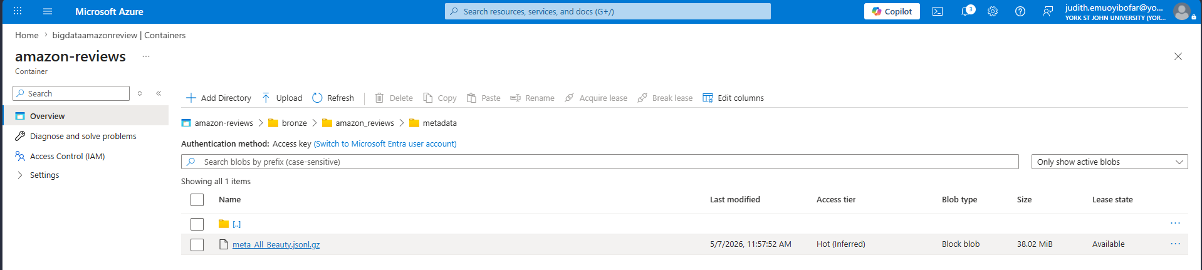
Figure 5: Screen showing data upload to the storage account (b)

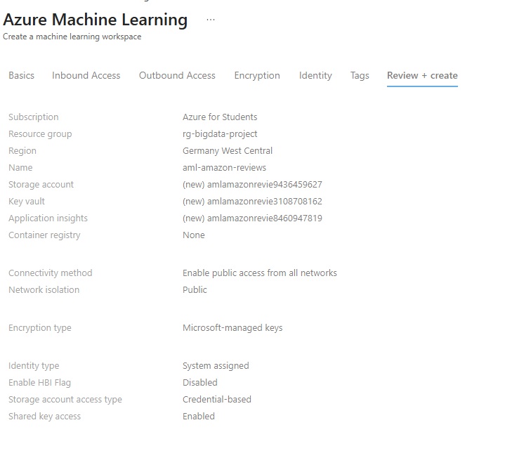
Figure 6: Screenshot showing the creation of Azure Machine learning workspace
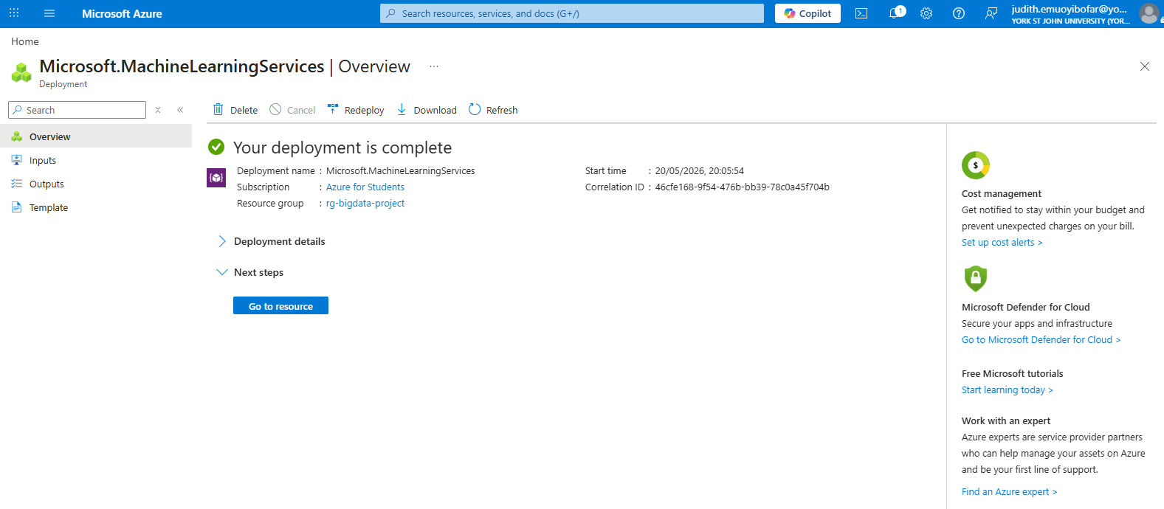
Figure 7: Screenshot showing the Machine learning workspace overview (a)
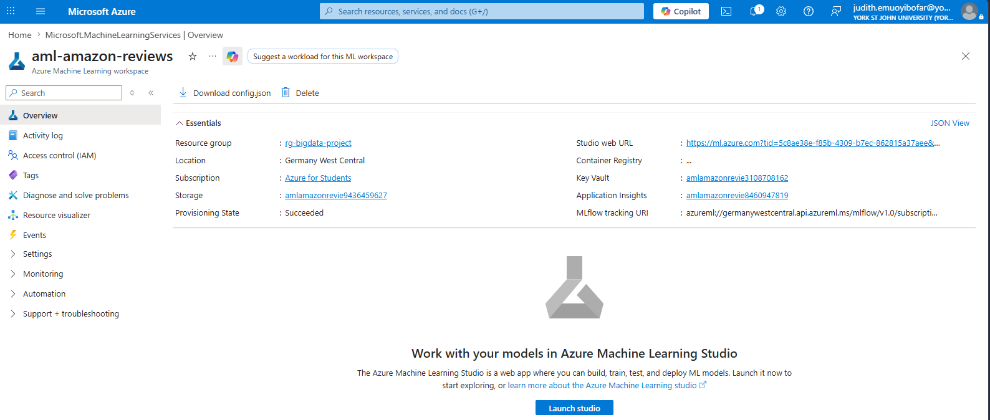
Figure 8: Screenshot showing the Machine learning workspace overview (b)
Azure Machine Learning Workspace was selected as the primary analytical environment due to its seamless integration with Azure cloud services, support for scalable machine learning workflows, and compatibility with Python-based big data analytics frameworks. The platform provides an enterprise-grade environment for data preprocessing, exploratory analysis, and machine learning model development.

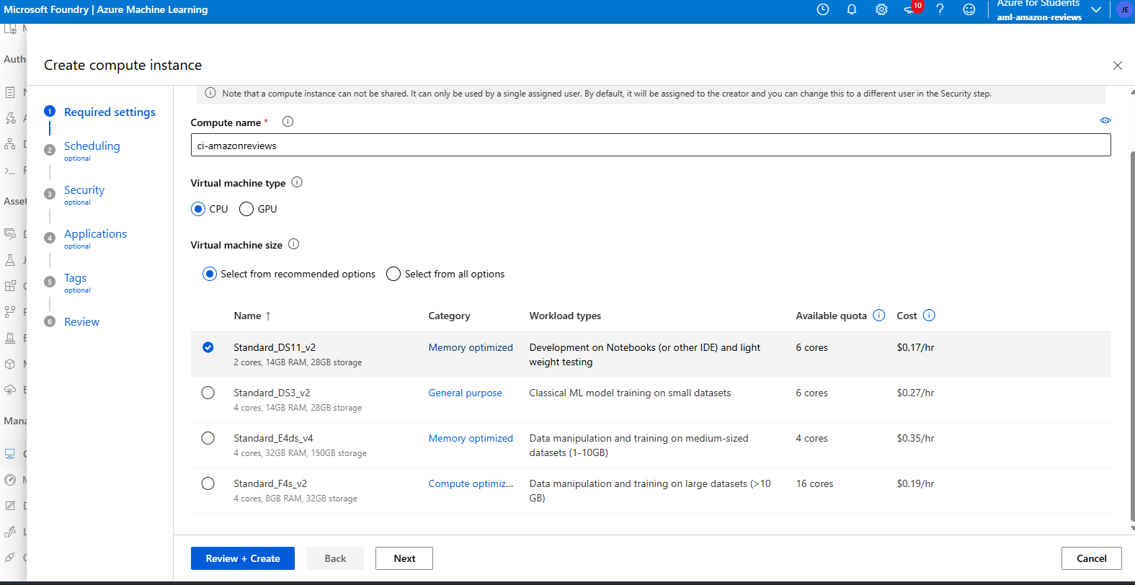
Figure 9: Screenshot showing the creation of a compute instance (a)
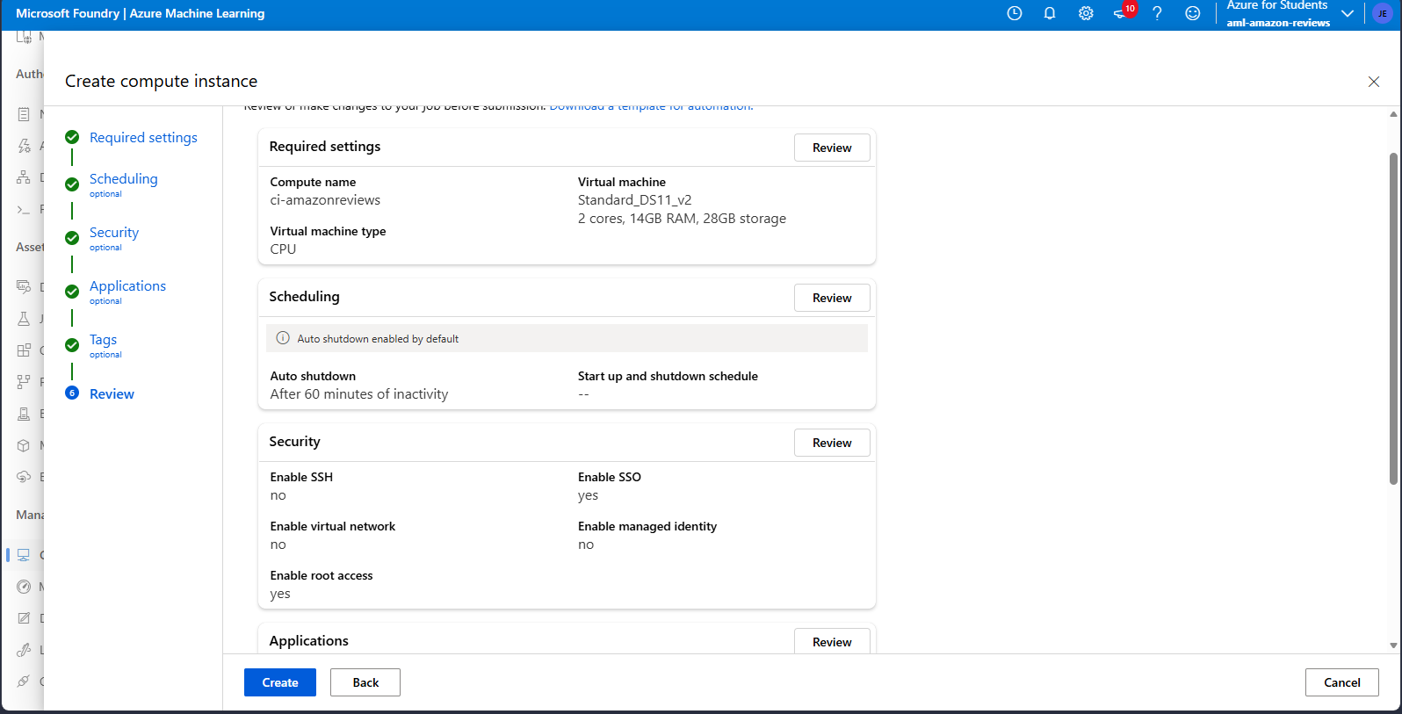
Figure 10: Screenshot showing the creation of copute instance (b)
A cloud-based compute instance was provisioned within Azure Machine Learning Workspace to support scalable data preprocessing and analytical workloads. Lightweight CPU-based infrastructure was selected to minimize operational cost while maintaining sufficient computational capability for exploratory analytics and machine learning experimentation.
The Amazon Beauty Reviews dataset was successfully ingested into the Azure Machine Learning notebook environment using Python and the Pandas library. The dataset was stored in compressed JSON Lines (.jsonl.gz) format to reduce storage overhead and improve transfer efficiency within the cloud environment.

Data Extraction Process
The extraction process involved transferring the compressed Amazon Beauty Reviews dataset into the enterprise cloud environment for analytical processing. The workflow began with uploading the datasets into Azure Data Lake Storage Gen2, which served as the organisation’s scalable cloud storage repository.
For analysis and experimentation, the datasets were then accessed within Microsoft Azure Machine Learning notebooks using Python and the Pandas library. Since the dataset was stored in compressed JSON Lines format, the extraction process required the use of parameters capable of handling both line-delimited JSON records and gzip compression.
The lines=True parameter enabled the system to interpret each line as an independent JSON object, while compression='gzip' allowed direct ingestion of compressed files without manual decompression. The extracted records were transformed into a structured Pandas DataFrame to support preprocessing and downstream analytical operations.
This cloud-based extraction approach improved processing efficiency while reducing storage overhead and unnecessary compute consumption.

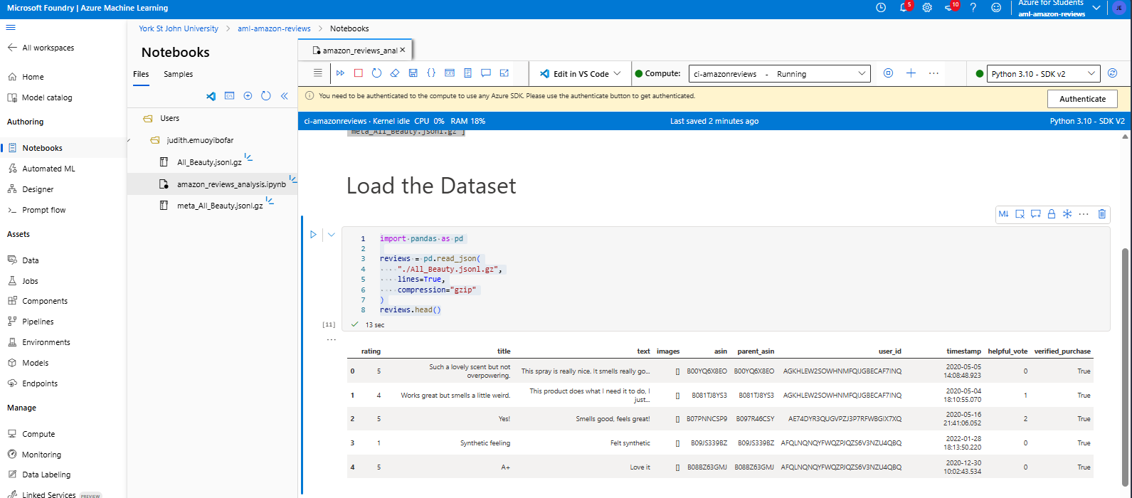
Figure 11: Screenshot showing how code was used to load the dataset directly without manual decompression
The lines=True parameter enabled the system to correctly process the JSON Lines structure, while compression='gzip' allowed seamless reading of the compressed file. The extracted data was transformed into a structured DataFrame, making it suitable for preprocessing, sentiment analysis, and machine learning tasks within the Azure cloud analytics environment.

Data Pre-processing
After extraction, several preprocessing operations were performed to clean and prepare the dataset for analysis and machine learning tasks. Since customer review datasets often contain inconsistent and incomplete records, preprocessing was necessary to improve data quality and analytical reliability.
The preprocessing steps included:
Data Overview – Inspecting the Dataset Structure
Table 1: Dataset Overview
Feature | Observation
Dataset Size | 701,528 reviews
Data Format | Semi-structured JSON
Timestamp | Successfully converted
Missing Values | None in core columns
Review Text | Available for NLP
Ratings | Structured numerical feature
Verified Purchases | Boolean analytical feature

The dataset contained approximately 701,528 customer review records and 10 analytical attributes, including review ratings, review text, timestamps, product identifiers, helpful votes, and purchase verification indicators.
The inspection process confirmed that the dataset contained no missing values within the primary analytical fields, thereby reducing the need for extensive null-value remediation. Additionally, the timestamp attribute was successfully interpreted in datetime format, enabling future temporal analysis of customer review behavior.
The dataset consisted of a combination of numerical, categorical, textual, boolean, and datetime features, demonstrating the heterogeneous nature of enterprise big data environments. The structured review ratings and unstructured textual review content made the dataset highly suitable for Natural Language Processing (NLP), sentiment analysis, and predictive analytics tasks.

Handling of Missing and Non-Informative Values
An exploratory data quality assessment was conducted to identify missing, null, and non-informative values within the Amazon Beauty Reviews dataset. The inspection revealed that the primary analytical attributes, including review ratings, review text, timestamps, product identifiers, and purchase verification indicators, contained no missing values.
However, further examination showed that the images column predominantly contained empty list values represented as []. Although these entries were not technically classified as null values, they did not contain meaningful analytical information and therefore contributed little value to the intended Natural Language Processing (NLP) and sentiment analysis tasks.
As a result, the images attribute was excluded from the analytical dataset during preprocessing to reduce unnecessary data complexity and improve processing efficiency. This decision allowed the analysis to focus on more relevant features such as review text, ratings, helpful votes, and purchase verification status.

Duplicate Record Identification and Removal
During the preprocessing stage, duplicate review records were identified within the Amazon Beauty Reviews dataset. A total of 7,275 duplicate observations were detected across the analytical attributes. Duplicate records can negatively affect analytical reliability by introducing redundancy, skewing statistical summaries, and biasing machine learning outputs.
To improve data quality and ensure analytical consistency, duplicate records were removed using the Pandas drop_duplicates() function.

Feature Selection
To improve analytical efficiency and reduce unnecessary data complexity, only features directly relevant to sentiment analysis, customer behavior evaluation, and business intelligence generation were retained. The selected attributes included customer ratings, review titles, review text, product identifiers, timestamps, helpful vote counts, and verified purchase indicators.
The user_id attribute was excluded from the analytical dataset because it provided limited value for the intended Natural Language Processing (NLP) and sentiment analysis tasks. Additionally, removing user-specific identifiers supported data minimization and privacy-oriented preprocessing practices commonly adopted in enterprise analytics environments.

Text Cleaning and Normalization:
To prepare the dataset for Natural Language Processing (NLP) and sentiment analysis tasks, textual review data underwent a text cleaning and normalization process within the Azure Machine Learning environment.
The preprocessing operations included:
- conversion of review text to lowercase
- removal of punctuation marks
- elimination of special characters
- normalization of excessive whitespace
These operations improved textual consistency, reduced noise within the dataset, and enhanced the effectiveness of downstream machine learning and sentiment analysis algorithms.

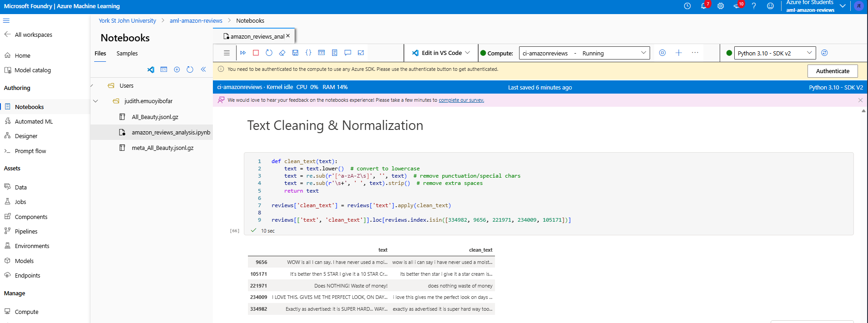
Figure 12: Screenshot showing how text columns was cleaned and normalized

Data Analysis and Insights

Cloud-Based Analytics Implementation
A cloud-based sentiment analysis solution was implemented within the Microsoft Azure Machine Learning environment to analyses customer opinions and behavioral trends within the Amazon Beauty Reviews dataset.
Natural Language Processing (NLP) techniques were applied using the TextBlob Python library to evaluate customer review polarity. Sentiment scores were generated for each customer review based on textual emotional expression, with polarity values ranging from negative to positive sentiment.
The sentiment analysis workflow was executed using Python-based analytical pipelines hosted within the Azure cloud environment, thereby demonstrating scalable cloud-native analytics capabilities for large-scale unstructured datasets.
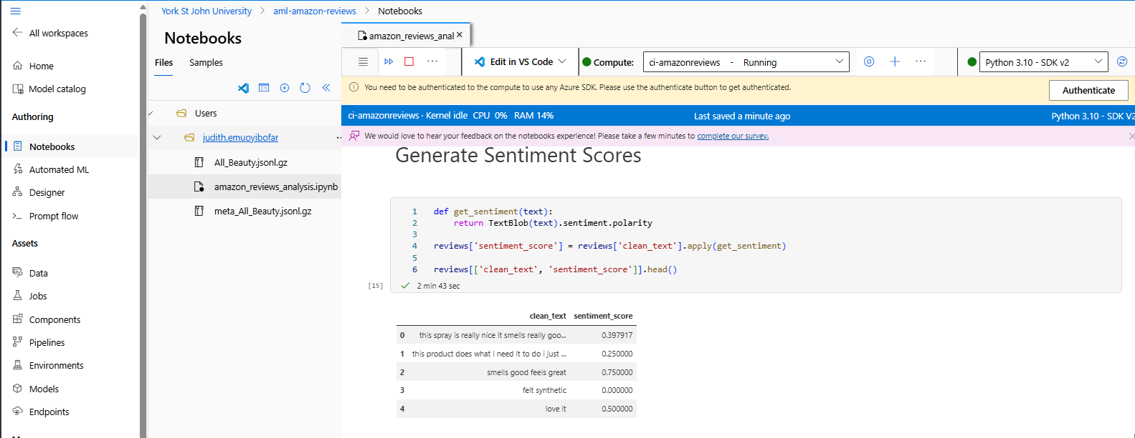
Figure 13: Screenshot showing Sentiment score on the text column
Table 2: Sentiment score definition
Sentiment | Score
Positive | > 0
Neutral | = 0
Negative | < 0

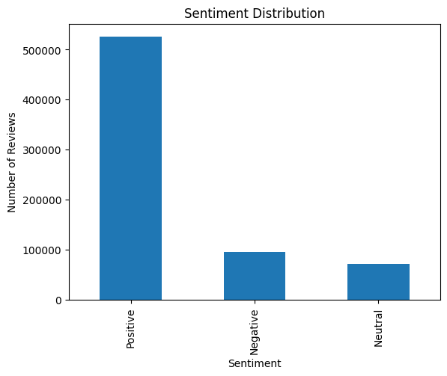
Chart 1: Text review was more positive than negative

Customer Rating Distribution Analysis
To evaluate customer satisfaction and product perception trends, rating distribution analysis was performed on the Amazon Beauty Reviews dataset within the Microsoft Azure Machine Learning environment.
The analysis examined the frequency distribution of customer product ratings across the 1-to-5-star rating scale. This enabled the identification of dominant customer satisfaction patterns and provided insight into overall product performance within the dataset.
The rating distribution was subsequently visualized using bar charts generated with the Matplotlib library to improve interpretability of customer feedback trends.
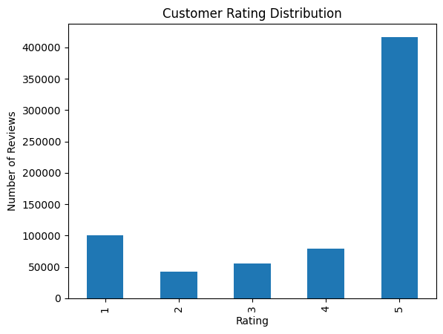
Chart 2: We have more 5-star ratings from the distribution as seen
Table 3: Customers Ratings definition
Insight | Meaning
More 5-star ratings | High customer satisfaction
More 1-star ratings | Product/service issues
Balanced distribution | Mixed customer experience

Helpful vote Analysis (Engagement Insight)
Helpful vote analysis was conducted to evaluate the level of customer engagement and determine how users interact with product reviews within the Amazon Reviews dataset. The number of helpful votes associated with each review provides an indication of how valuable or influential a review is to other customers.
The analysis examined the relationship between customer ratings and the average number of helpful votes received.
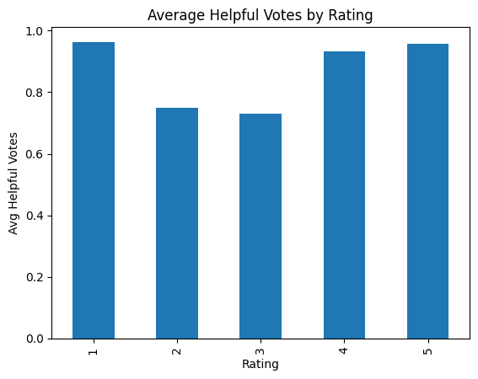
Chart 3: The visualization above illustrates the relationship between customer ratings and the average number of helpful votes received across reviews within the dataset.
The analysis shows that reviews associated with 1-star and 5-star ratings received the highest average helpful votes, while reviews with moderate ratings such as 2-star and 3-star reviews received comparatively lower engagement levels.
This pattern suggests that customers are more likely to interact with reviews expressing strong opinions or experiences, whether highly positive or highly negative. Extreme reviews often contain detailed feedback, emotional reactions, or important product insights that other users may consider valuable when making purchasing decisions.
Additionally, the relatively high helpful vote count observed for 4-star and 5-star reviews may indicate that positive customer experiences tend to resonate more strongly with other buyers. Conversely, highly rated helpful negative reviews may highlight significant product concerns or warnings that attract user attention.
From a business intelligence perspective, this analysis provides several important insights:
- Reviews with strong sentiment tend to influence customer engagement more significantly.
- Helpful votes can serve as an indicator of review credibility and customer trust.
- Businesses can prioritize highly engaged reviews to better understand customer expectations and product perception.
- E-commerce platforms may use helpfulness metrics to improve review ranking and recommendation systems.

Verified Purchase Analysis
The verified purchase analysis was conducted to evaluate the authenticity and reliability of customer reviews within the dataset. The verified_purchase attribute indicates whether a customer actually purchased the product before submitting a review. 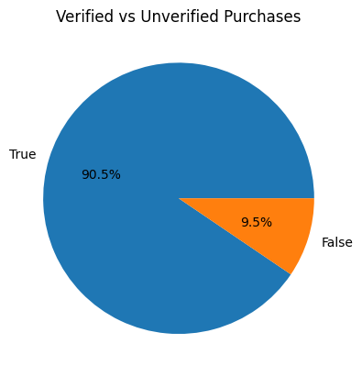
Chart 4: The results revealed that approximately 90.5% of all reviews were submitted by verified purchasers, while only about 9.5% originated from unverified purchases.
The pie chart visualization clearly demonstrates that the overwhelming majority of customer feedback within the dataset comes from genuine product buyers. This significantly improves the credibility and trustworthiness of the analytical results, particularly for sentiment analysis and customer behavior evaluation. The high proportion of verified reviews suggests that the dataset is relatively reliable for business intelligence analysis, customer opinions are more likely to reflect real product experiences, and the influence of potentially fake or manipulated reviews is minimized.
Additionally, verified reviews are generally considered more valuable in e-commerce environments because they are often based on actual product usage and customer satisfaction levels.
From a business and analytical perspective, this insight is highly important because verified reviews improve confidence in sentiment analysis outcomes, organizations can make more accurate product performance assessments, and businesses can better understand authentic customer needs and expectations.
Furthermore, e-commerce platforms commonly prioritize verified reviews when displaying customer feedback, as they help strengthen buyer trust and improve purchasing decision-making processes.

Word Frequency Analysis
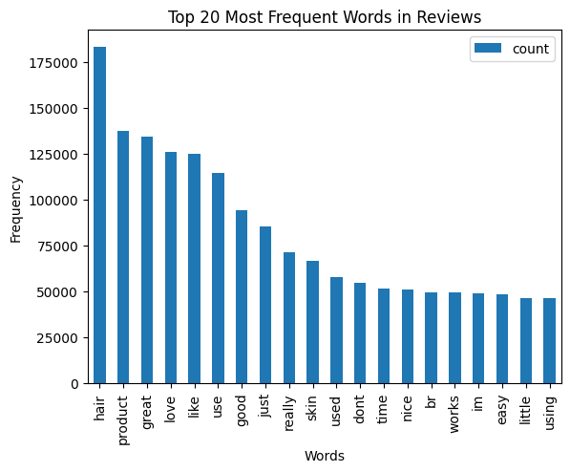
Chart 5: The word frequency analysis was conducted to identify the most commonly occurring words within customer reviews after the text preprocessing and normalization stage.
This Natural Language Processing (NLP) technique helps uncover recurring themes, customer perceptions, and behavioral patterns within the dataset.
The analysis revealed that words such as “hair,” “product,” “great,” “love,” “like,” “good,” and “works” appeared most frequently across customer reviews. The high occurrence of these terms suggests that customers were primarily discussing product quality, usability, effectiveness, and overall satisfaction.
The most frequently occurring term was “hair”, indicating that a significant portion of the dataset relates to hair-related products or beauty and personal care items. Additionally, strongly positive terms such as “great,” “love,” “good,” “nice,” and “works” appeared repeatedly, suggesting generally favorable customer experiences and positive sentiment within the dataset.
The analysis also identified commonly used conversational terms such as “just,” “really,” “time,” and “using,” which reflect descriptive customer experiences and product usage discussions.
The bar chart visualization further highlighted the dominance of positive and product-oriented terminology within the reviews, reinforcing the findings from the earlier sentiment analysis where positive reviews constituted the majority of customer feedback.
From a business intelligence perspective, the word frequency analysis provides valuable insights because it identifies key themes driving customer discussions, highlights frequently mentioned product characteristics, supports customer sentiment interpretation, and enables organizations to better understand consumer priorities and expectations.
Furthermore, organizations can leverage this type of analysis to improve product development strategies, optimize marketing campaigns, identify recurring customer concerns, and enhance overall customer experience management.

Machine Learning Model – Sentiment Classification

Analysis Overview
A machine learning-based sentiment classification model was developed to automatically predict customer sentiment from textual review data. The objective of the model was to classify reviews into positive, neutral, or negative sentiment categories based on customer review content.
To achieve this, Natural Language Processing (NLP) techniques and supervised machine learning algorithms were implemented within the cloud analytics workflow.

Feature Engineering and Text Vectorization
The cleaned textual review data was transformed into numerical representations using the TF-IDF (Term Frequency–Inverse Document Frequency) vectorization technique. TF-IDF helps identify the importance of words within documents while reducing the influence of overly common terms.

Model Training
A Logistic Regression algorithm was selected due to its efficiency and strong performance in text classification problems.

Model Evaluation
The comparative results are presented below:
Table 4: Model Accuracy Comparison
Model | Accuracy
Logistic Regression | 95.47%
Naïve Bayes | 80.36%
Random Forest | 88.98%

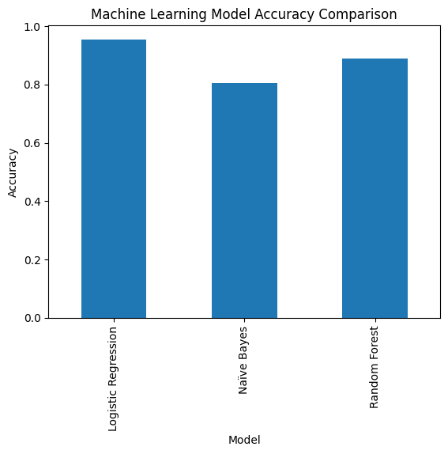
Chart 6: Machine Learning Model Accuracy Comparison
The results indicate that the Logistic Regression model achieved the highest predictive performance with an accuracy score of approximately 95.47%, outperforming both the Naïve Bayes and Random Forest models. This suggests that Logistic Regression was more effective in learning sentiment patterns from the large-scale textual review dataset.
The Naïve Bayes model produced the lowest accuracy score among the evaluated algorithms. Although computationally efficient and commonly used for text classification problems, its simplifying probabilistic assumptions may have limited its predictive capability within the complex customer review dataset.
The Random Forest model demonstrated relatively strong performance with an accuracy score of approximately 88.98% at 10 n_estimators. Its ensemble-based learning approach improved classification robustness; however, it did not outperform Logistic Regression in this particular NLP classification task.
Overall, the comparative evaluation demonstrates the importance of model experimentation when designing enterprise machine learning solutions for large-scale big data environments. The findings suggest that Logistic Regression provided the most suitable balance between predictive accuracy, computational efficiency, and scalability for customer sentiment classification within the cloud-based analytics architecture.

Contribution of the Analysis to Informed Decision-Making within the Enterprise
The cloud-based analytical framework implemented on the Amazon Beauty Reviews dataset provides valuable business intelligence that supports informed decision-making across multiple operational and strategic areas within the enterprise.
Firstly, the sentiment analysis conducted on customer review text enabled the organization to understand overall customer perception toward products. By categorizing customer feedback into positive, neutral, and negative sentiments, the enterprise can rapidly identify customer satisfaction trends, detect recurring complaints, and monitor public perception of products at scale. This supports proactive customer experience management and faster response to quality-related concerns.
Secondly, the rating distribution analysis provided insight into customer satisfaction levels and product performance trends. Products with consistently high ratings indicate strong market acceptance and can be prioritized for inventory expansion, promotional activities, and targeted marketing campaigns. Conversely, products receiving lower ratings may require quality reviews, pricing adjustments, or supplier evaluation.
The helpful vote analysis also contributed meaningful business intelligence by identifying reviews perceived by customers as highly useful or trustworthy. This enables the enterprise to better understand which product issues or customer experiences are most influential in purchasing decisions.
Furthermore, the verified purchase analysis improved the reliability of customer feedback interpretation by distinguishing authentic customer experiences from potentially less reliable reviews. This strengthens confidence in analytical outcomes and improves decision-making accuracy.
In addition to descriptive analytics, machine learning models such as Logistic Regression, Naïve Bayes, and Random Forest were implemented to automate sentiment classification across large-scale review data. The comparative model evaluation demonstrated that Logistic Regression achieved the highest predictive accuracy, making it the most suitable model for scalable sentiment prediction within the enterprise environment.
Collectively, these analytical processes contribute to:
- improved customer satisfaction monitoring
- enhanced product quality assessment
- data-driven marketing and inventory decisions
- faster identification of customer dissatisfaction trends
- scalable automation of customer feedback analysis
- improved strategic planning using real-time business intelligence
The use cloud-based big data processing technologies also ensures that the enterprise can continue analyzing growing data volumes efficiently without significant infrastructure limitations. This provides the organization with a scalable, intelligent, and cost-effective analytics ecosystem capable of supporting modern enterprise decision-making requirements.

Cost Optimization Strategies
Efficient cost management is a critical consideration when designing enterprise-scale cloud-based big data architectures. Since the Amazon Beauty Reviews dataset contains hundreds of thousands of large semi-structured review records, several cost optimization strategies were implemented within the Microsoft Azure cloud environment to reduce storage, processing, and compute expenses while maintaining analytical performance and scalability.

Cost-Effective Cloud Storage Strategy
The enterprise adopted Microsoft Azure Data Lake Storage Gen2 as the primary storage platform due to its scalability, durability, and relatively low storage costs for large unstructured and semi-structured datasets.
Several storage optimization techniques were applied:
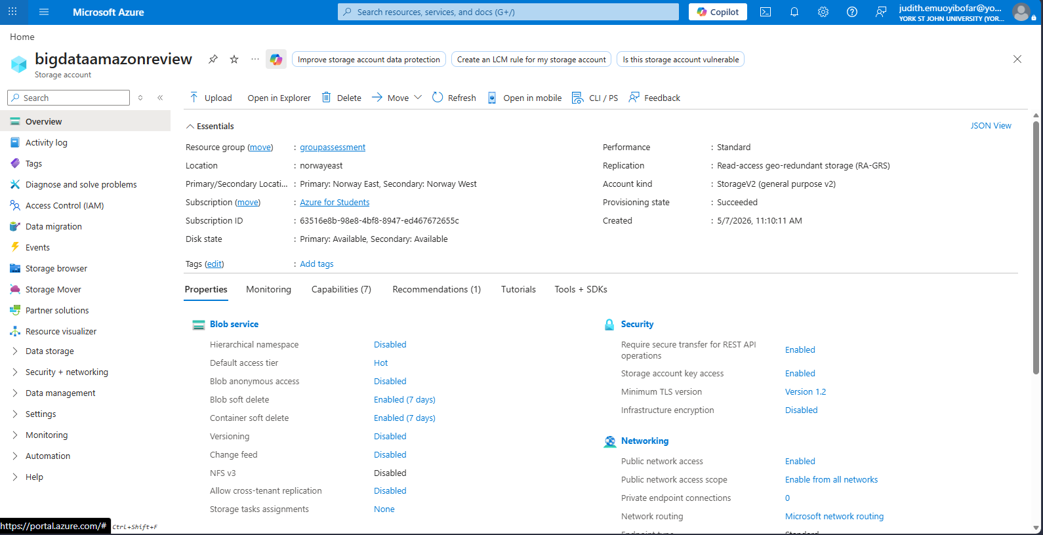
Figure 14: Screenshot showing storage account overview

Compressed File Storage
The dataset was retained in compressed.jsonl.gz format rather than uncompressed JSON format. Compression significantly reduced storage consumption and lowered cloud storage costs while also improving transfer efficiency.
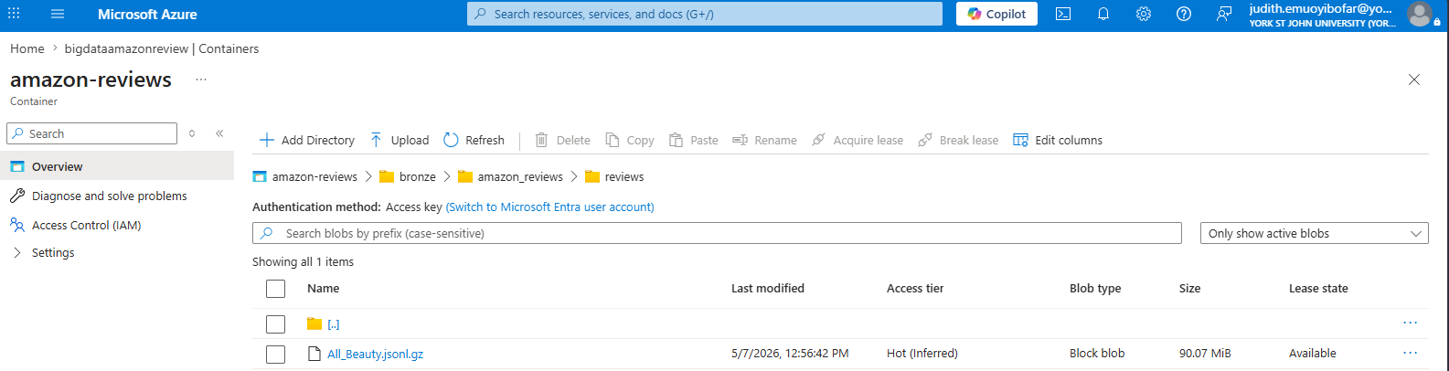
Figure 15: Screenshot showing data storage in compressed format

Tiered Storage Strategy
Azure Storage access tiers were considered for lifecycle management:
Hot Tier → frequently accessed analytical datasets
Cool Tier → infrequently accessed historical datasets
Archive Tier → long-term retention and backup storage
This lifecycle-based approach reduces unnecessary high-cost storage allocation for dormant data.

Data Minimization
Non-essential attributes such as the image’s column containing predominantly empty values were excluded during preprocessing. This reduced memory utilization and processing overhead during analytics operations.

Compute Resource Optimization
To optimize analytical processing costs, lightweight cloud compute resources were used within the Azure Machine Learning environment rather than deploying high-cost distributed clusters continuously.
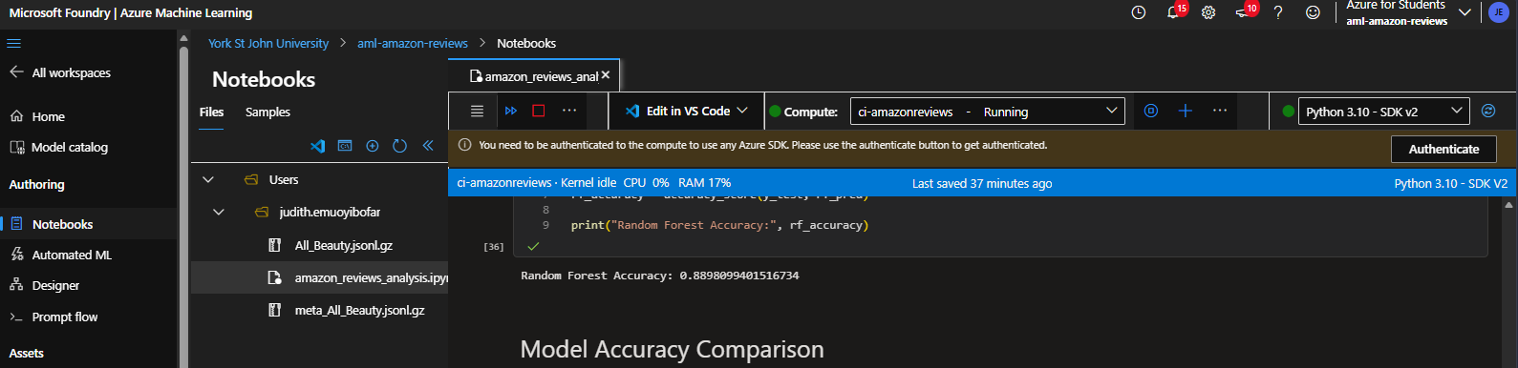
Figure 16: Screenshot showing cloud-based compute configuration
Table 5: Compute configuration overview
Resource Component | Configuration
Platform | Azure Machine Learning
Compute Name | cl-amazonreviews
Status | Running
Kernel Type | Python 3.10 – SDK v2
CPU Allocation | 2 CPU Cores
Memory Allocation | 7 GB RAM

On-Demand Compute Usage
Compute instances were started only during active analytical sessions and shut down immediately after processing tasks were completed. This prevented unnecessary compute billing during idle periods.

Scalable Compute Allocation
Smaller compute configurations were initially used during exploratory data analysis and preprocessing phases, while larger compute resources were reserved only for machine learning training operations when required.

Efficient Model Selection
The Logistic Regression model achieved the highest predictive accuracy while maintaining relatively low computational complexity compared to more resource-intensive ensemble algorithms. This improved both performance efficiency and cost-effectiveness.

Resource Utilization Optimization
Efficient resource utilization strategies were implemented to minimize unnecessary cloud consumption:
- preprocessing reduced duplicate records and irrelevant features
- compressed datasets reduced memory usage
- TF-IDF vectorization transformed text efficiently for machine learning
- unnecessary columns were excluded from analysis
- lightweight Python libraries were prioritized where possible
These optimizations reduced CPU usage, storage overhead, and notebook execution time.

Reserved Instances and Pricing Optimization
Although the project primarily used on-demand student cloud resources, enterprise deployment recommendations include:
Reserved Compute Instances
For long-term production workloads, Azure Reserved Virtual Machine Instances can significantly reduce compute costs compared to pay-as-you-go pricing models.
Auto-Scaling Policies
Dynamic auto-scaling policies can allocate additional compute resources only during peak processing periods and automatically reduce resources during low-utilization periods.
Serverless Processing
Where appropriate, serverless analytical services may further reduce costs by charging only for actual processing time rather than continuously running infrastructure.

Monitoring and Cost Governance
The enterprise can further optimize operational expenditure using:
- Azure Cost Management
- Azure Monitor
- budget alerts
- resource tagging
- usage analytics dashboards
These services improve visibility into cloud spending patterns and support proactive cost governance strategies.
The implemented cost optimization strategies ensured that the enterprise could efficiently process and analyses large-scale customer review data within the Azure cloud environment while controlling infrastructure and operational costs. By combining scalable storage, lightweight analytical compute resources, compressed data formats, and efficient preprocessing techniques, the proposed architecture achieved a balanced trade-off between performance, scalability, and financial sustainability.

Security and Compliance

Security Measures for Data Confidentiality and Integrity
Ensuring the confidentiality, integrity, and protection of enterprise data is a critical requirement within cloud-based big data environments, particularly when processing large-scale customer-generated datasets such as the Amazon Beauty Reviews dataset. Several security measures were implemented and recommended within the Microsoft Azure cloud environment to safeguard sensitive analytical assets and maintain secure data operations.
- Secure Cloud Storage
The dataset was stored within Microsoft Azure Data Lake Storage Gen2, which provides enterprise-grade security capabilities including:
- data encryption
- access control
- secure authentication
- redundancy protection
This ensured that customer review data remained protected both during storage and analytical processing.
- Encryption at Rest and In Transit
To maintain data confidentiality and integrity: data stored within Azure Storage was protected using server-side encryption
secure HTTPS/TLS protocols were used during data transfer between cloud services
These encryption mechanisms reduced the risk of unauthorized interception or exposure of customer-generated data.
- Identity and Access Management (IAM)
Role-Based Access Control (RBAC) was implemented to restrict access to authorized personnel only. This ensured that:
- data scientists could access analytical environments
- administrators could manage infrastructure resources
- unauthorized users were prevented from accessing sensitive datasets
The principle of least privilege was applied to minimize unnecessary access permissions.

- Secure Analytical Environment
The Azure Machine Learning environment used for preprocessing and machine learning operations was protected using authenticated Azure accounts and controlled workspace permissions. This reduced the risk of unauthorized notebook access and protected analytical workflows from external compromise.

- Data Integrity Protection
Data integrity was maintained through:
- controlled cloud storage permissions
- centralized data management
- version-controlled analytical notebooks
- duplicate removal and preprocessing validation
These controls ensured that analytical outputs were generated from consistent and reliable datasets.

Compliance Considerations in Regulated Industries
Enterprises operating in regulated industries such as healthcare, finance, telecommunications, and e-commerce must comply with strict data governance and privacy regulations. Although the Amazon Beauty Reviews dataset is publicly available, the proposed cloud architecture was designed with broader enterprise compliance considerations in mind.

- Data Privacy and Protection
The preprocessing stage excluded unnecessary user-identifiable information such as user_id from downstream analysis wherever possible. This supported data minimization principles commonly associated with:
- GDPR (General Data Protection Regulation)
- data privacy governance frameworks
- enterprise compliance standards

- Auditability and Governance

Azure cloud services provide auditing and monitoring capabilities that enable enterprises to:
- track data access
- monitor analytical activities
- maintain security logs
- support compliance reporting requirements

- Regulatory Compliance Support
Microsoft Azure cloud services support compliance with multiple international regulatory frameworks including:
- GDPR
- ISO 27001
- SOC 2
- HIPAA
- PCI-DSS
This makes the proposed architecture suitable for enterprise deployment within highly regulated sectors.

- Data Residency and Governance
Cloud-based storage and analytics environments also support regional deployment strategies that allow enterprises to comply with country-specific data residency requirements and governance policies.

The implemented security and compliance strategies ensured that the cloud-based big data analytics environment maintained strong confidentiality, integrity, and governance standards throughout the data lifecycle. By combining encryption, access control, secure cloud storage, and compliance-oriented data governance practices, the enterprise can confidently process and analyses large-scale datasets while minimizing security risks and supporting regulatory compliance obligations.

Access Control Mechanisms and Encryption Practices
To protect the Amazon Beauty Reviews dataset throughout the cloud analytics process, several security controls and encryption practices were implemented within the Microsoft Azure environment. These measures were designed to ensure that only authorized users could access the data while maintaining the confidentiality and integrity of the analytical environment.

Access Control Mechanisms
- Role-Based Access Control (RBAC)
Role-Based Access Control (RBAC) was used to manage user permissions across Azure Storage and Azure Machine Learning services. Instead of giving every user full access to the system, permissions were assigned based on specific job responsibilities.
For example:
Table 6: Role base access control
Role | Access Level
Data Architect | Full access to storage and analytics resources
Data Scientist | Access to datasets and machine learning notebooks
Business Analyst | Read-only access to reports and dashboards
System Administrator | Infrastructure and security management

This approach reduced the risk of unauthorized access and ensured that sensitive datasets were only accessible to approved personnel.
- Principle of Least Privilege
The principle of least privilege was also applied throughout the environment. This means users were only given the minimum permissions necessary to perform their tasks.
For instance:
- analysts could view processed datasets but could not alter raw storage files
- external collaborators were restricted from administrative functions
- machine learning notebooks accessed only approved datasets
This helped reduce security risks and improve overall governance of the cloud environment.

- Multi-Factor Authentication (MFA)
Multi-Factor Authentication was enabled for Azure accounts to provide an additional layer of security. In addition to usernames and passwords, users were required to verify their identities through secondary authentication methods such as mobile verification codes.
This significantly reduced the likelihood of unauthorized access caused by compromised credentials.

- Secure Workspace Permissions
Access to:
- Azure Data Lake Storage Gen2
- Azure Machine Learning Workspace
- analytical notebooks and datasets
was managed through Azure Active Directory authentication and workspace-level permissions. This ensured that only authenticated enterprise users could access the cloud analytics environment.

Encryption Practices
- Encryption at Rest
The datasets stored within Azure Data Lake Storage Gen2 were protected using Azure’s built-in server-side encryption. This automatically encrypted stored files and analytical outputs to prevent unauthorized access at the storage level.
As a result:
- raw datasets
- processed analytical files
- machine learning outputs
remained protected while stored in the cloud.
- Encryption in Transit
All communication between Azure services used secure HTTPS and TLS protocols. This encrypted data while it was being transferred between:
- Azure Storage
- Azure Machine Learning
- cloud notebooks
- analytics services
This prevented data interception or tampering during transmission.
- Secure Access Tokens
Where temporary access to cloud storage resources was required, Shared Access Signatures (SAS tokens) were used instead of exposing permanent storage credentials. These tokens provided controlled and time-limited access to storage resources, improving security and reducing the risk of credential misuse.

- Data Minimisation
During preprocessing, unnecessary user-related attributes such as user_id were excluded from the analytical workflow where possible. This supported privacy-focused analytics practices and reduced the exposure of potentially sensitive information.

The combination of RBAC, least privilege access, secure authentication, and encryption mechanisms provided a strong security foundation for the cloud-based analytics environment. These practices ensured that the Amazon Beauty Reviews dataset remained protected throughout storage, preprocessing, machine learning, and analytical operations within the Azure ecosystem.

Performance Monitoring and Troubleshooting
Monitoring the performance of a cloud-based big data processing system is essential to ensure reliable analytics, efficient resource utilization, and consistent machine learning performance. Since the Amazon Beauty Reviews dataset contains over 700,000 customer review records with large volumes of unstructured text data, several monitoring and troubleshooting strategies were considered within the Microsoft Azure cloud environment.

Performance Monitoring Strategies
- Monitoring Compute Resource Utilization
Within the Azure Machine Learning environment, compute resource usage such as: CPU utilization, memory consumption, storage usage, notebook execution time was monitored regularly during preprocessing and machine learning operations. This helped identify situations where analytical tasks consumed excessive resources, particularly during TF-IDF vectorization, sentiment analysis, machine learning model training. Monitoring resource utilization ensured that compute instances were appropriately sized for the workload without generating unnecessary cloud costs.
- Dataset Size and Processing Monitoring
Because the dataset contained hundreds of thousands of customer reviews, processing performance was monitored to identify delays caused by large-scale text operations.
Tasks such as: loading compressed.jsonl.gz files, duplicate removal, text cleaning Vectorization, were monitored to ensure that processing remained efficient and scalable within the cloud environment. Using compressed dataset formats reduced loading time and improved storage efficiency during analytical operations.
- Model Performance Monitoring
Machine learning model performance was evaluated continuously using: accuracy score, precision, recall, F1-score. This helped determine whether the predictive models were producing reliable sentiment classification results.
The comparison between Logistic Regression, Naïve Bayes, and Random Forest models also supported performance optimization by identifying the model with the best balance between computational efficiency and predictive accuracy.
- Cloud Monitoring Tools
Enterprise deployments can further utilize Azure monitoring services such as: Azure Monitor, Azure Log Analytics, Azure Cost Management. These services provide real-time visibility into: resource usage, system health, notebook failures, processing delays, storage consumption. This enables proactive monitoring and early detection of performance bottlenecks.

Troubleshooting and Bottleneck Management
- Managing Memory Bottlenecks
Large NLP datasets can consume significant memory during text vectorization and machine learning operations. To reduce memory pressure unnecessary columns were removed, duplicate records were dropped, compressed files were used, lightweight preprocessing techniques were applied. These optimizations improved notebook stability and reduced the likelihood of runtime crashes. Handling Slow Processing Times
Text preprocessing and TF-IDF vectorization can become computationally expensive when working with large review datasets. To manage this: efficient Pandas operations were used, irrelevant features were excluded, smaller compute instances were used initially, processing workloads were simplified where possible. This improved execution speed while maintaining analytical quality.

- Managing Failed Package Installations
During implementation, issues such as missing NLP libraries (for example, TextBlob installation errors) were encountered within the Azure Machine Learning notebook environment. These were resolved by: installing packages directly into the active runtime environment, restarting notebook kernels after installation, validating dependencies before analysis execution.
This ensured stable execution of sentiment analysis workflows.

- Data Quality Validation
Potential analytical issues caused by inconsistent or redundant data were managed through preprocessing operations such as: duplicate removal, empty column detection, feature selection, text normalization. These steps improved data consistency and enhanced the reliability of machine learning outputs.

The monitoring and troubleshooting strategies implemented within the Azure cloud environment ensured stable, scalable, and efficient processing of the Amazon Beauty Reviews dataset. By continuously monitoring compute performance, machine learning accuracy, storage utilization, and preprocessing efficiency, the enterprise can maintain reliable analytical operations while minimizing bottlenecks and operational disruptions within large-scale cloud-based big data systems.

System Management and Monitoring Tools
Efficient management and monitoring of cloud-based big data environments are essential for maintaining system stability, optimizing performance, controlling operational costs, and ensuring reliable analytics execution. Within the proposed architecture for analyzing the Amazon Beauty Reviews dataset, several cloud-native tools and services available within the Microsoft Azure ecosystem were identified to support effective system administration, monitoring, and troubleshooting.
A. Azure Monitor
Microsoft Azure Monitor is one of the primary tools used for monitoring cloud infrastructure and analytical workloads. It provides real-time visibility into CPU utilization, memory consumption, storage performance, notebook execution metrics and network activity.
This enables administrators and data engineers to identify performance bottlenecks quickly and optimize cloud resource allocation during preprocessing, machine learning training, and sentiment analysis operations.
Azure Monitor also supports alert configuration, allowing administrators to receive notifications when resource usage exceeds predefined thresholds.

B. Azure Log Analytics
Azure Log Analytics helps collect and analyses logs generated by: Azure Machine Learning, storage accounts, compute instances, analytical notebooks. This service supports troubleshooting by enabling administrators to track failed notebook executions, authentication issues, package installation failures and resource connectivity problems. For example, during implementation, notebook dependency issues such as missing NLP libraries could be identified and resolved more efficiently through log monitoring and runtime diagnostics.

C. Azure Machine Learning Studio
Microsoft Azure Machine Learning Studio provides a centralized environment for managing machine learning experiments, datasets, notebooks, and compute resources.
The platform supports: experiment tracking, model performance monitoring, notebook management, compute instance administration, dataset versioning
This improved the overall management of the sentiment analysis and machine learning workflow implemented on the Amazon Beauty Reviews dataset.

- Azure Cost Management
Azure Cost Management was considered an important governance tool for monitoring cloud spending associated with storage usage, compute resources, notebook execution, machine learning workloads
The service enables enterprises to: track operational costs, identify underutilized resources, optimize compute allocation, establish spending alerts and budgets.
This is particularly important when processing large-scale datasets in cloud environments where uncontrolled resource usage may increase operational expenditure.

- Azure Storage Explorer
Azure Storage Explorer provides a user-friendly interface for managing cloud storage containers and datasets stored within Azure Data Lake Storage Gen2.
The tool enables administrators and analysts to upload datasets, monitor file organization, validate storage structures, manage access permissions and inspect dataset sizes.
This simplified the management of compressed dataset files such as All_Beauty.jsonl.gz and metadata files within the cloud storage environment.
The combination of Azure Monitor, Azure Log Analytics, Azure Machine Learning Studio, Azure Cost Management, and Azure Storage Explorer provides a comprehensive ecosystem for efficiently managing and monitoring cloud-based big data processing systems. These tools enable the enterprise to maintain system performance, optimize cloud resources, troubleshoot analytical issues quickly, and support scalable machine learning operations within the Azure cloud environment.

References
- Davenport, T.H. and Harris, J.G. (2017) Competing on Analytics: The New Science of Winning. Boston: Harvard Business Review Press.
- European Union (2018) General Data Protection Regulation (GDPR). Available at: GDPR Official Information (Accessed: 20 May 2026).
- Géron, A. (2022) Hands-On Machine Learning with Scikit-Learn, Keras and TensorFlow. 3rd edn. Sebastopol: O’Reilly Media.
- Han, J., Pei, J. and Kamber, M. (2011) Data Mining: Concepts and Techniques. 3rd edn. Waltham: Morgan Kaufmann.
- Marr, B. (2021) Data Strategy: How to Profit from a World of Big Data, Analytics and Artificial Intelligence. London: Kogan Page.
- Mell, P. and Grance, T. (2011) The NIST Definition of Cloud Computing. Gaithersburg: National Institute of Standards and Technology.
- Microsoft (2024) Azure Architecture Center. Available at: Azure Architecture Center (Accessed: 20 May 2026).
- Microsoft (2024) Azure Cost Management Documentation. Available at: Azure Cost Management Documentation (Accessed: 20 May 2026).
- Microsoft (2024) Azure Encryption Documentation. Available at: Azure Encryption Documentation (Accessed: 20 May 2026).
- Microsoft (2024) Azure Machine Learning Documentation. Available at: Azure Machine Learning Documentation (Accessed: 20 May 2026).
- Microsoft (2024) Azure Monitor Documentation. Available at: Azure Monitor Documentation (Accessed: 20 May 2026).
- Microsoft (2024) Azure Role-Based Access Control Documentation. Available at: Azure RBAC Documentation (Accessed: 20 May 2026).
- Microsoft (2024) Azure Security Documentation. Available at: Microsoft Azure Security Documentation (Accessed: 20 May 2026).
- Microsoft (2024) Azure Storage Documentation. Available at: Azure Storage Documentation (Accessed: 20 May 2026).
- Microsoft (2024) Azure Storage Pricing. Available at: Azure Storage Pricing (Accessed: 20 May 2026).
- Microsoft (2024) Azure Storage Security Guide. Available at: Azure Storage Security Guide (Accessed: 20 May 2026).
- Microsoft (2024) Azure VM Sizes Documentation. Available at: Azure VM Sizes Documentation (Accessed: 20 May 2026).
- Pedregosa, F. et al. (2011) ‘Scikit-learn: Machine Learning in Python’, Journal of Machine Learning Research, 12, pp. 2825–2830.
- Provost, F. and Fawcett, T. (2013) Data Science for Business. Sebastopol: O’Reilly Media.
- Russell, S. and Norvig, P. (2021) Artificial Intelligence: A Modern Approach. 4th edn. Harlow: Pearson.

Appendix

